Hall Effect
Name: Pargat Singh
Roll No: 16010121045
Branch: COMPS
Batch: A2

Aim:
1. To determine Hall Voltage developed across the sample material.
2. To calculate the Hall coefficient and the carrier concentration of the sample material.

Apparatus:
- Two solenoids
- Constant current supply
- Four probes
- Digital gauss meter
- Hall effect apparatus (consisting of current generator (CCG), digital milli voltmeter and Hall probe).

Diagram:

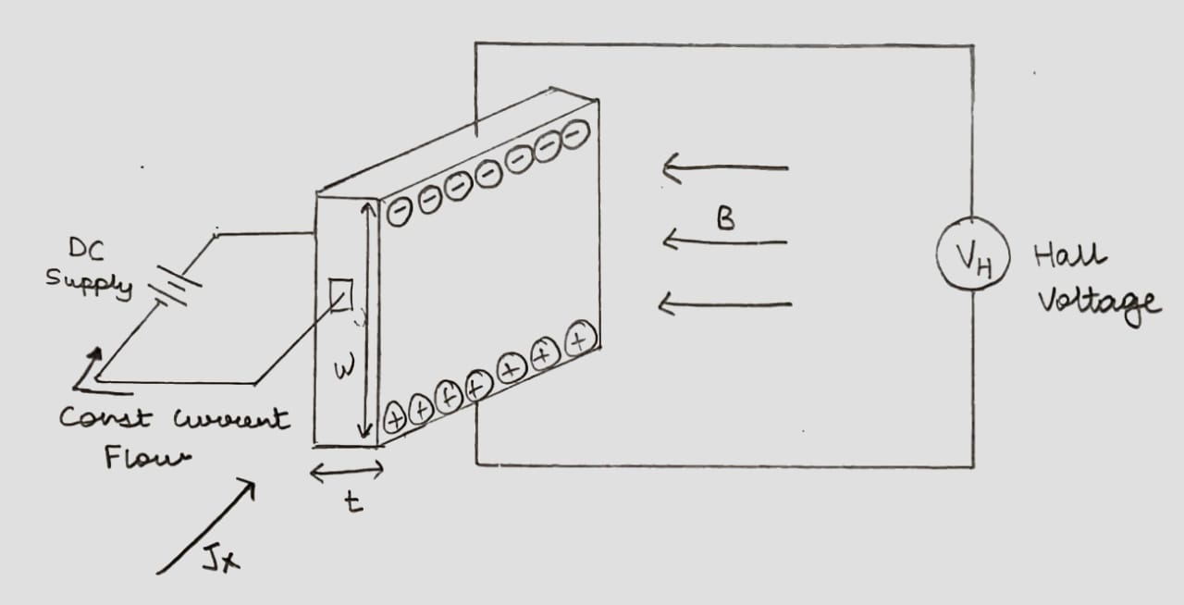

J_{X} (Current Density) = I/wt

B - Applied Magnetic Field
w - Width
t - Thickness
J_{X} - Current Density

Observation Table:
Material: Gold
Magnetic field B = 0.447 gauss = 0.447 x 10⁻⁴ tesla

Thickness t = 0.4 mm |  | Thickness t = 0.8 mm
I_{H} mA | V_{H} mV | I_{H} mA | V_{H} mV
1 | 778.181 | 1 | 389.091
1.5 | 1167.272 | 1.5 | 583.636
2 | 1556.362 | 2 | 778.181
2.5 | 1945.453 | 2.5 | 972.727
3 | 2334.544 | 3 | 1167.272
3.5 | 2723.634 | 3.5 | 1361.817
4 | 3112.725 | 4 | 1556.362
4.5 | 3501.816 | 4.5 | 1750.908
5 | 3890.906 | 5 | 1945.453

Graph:
Plot Hall voltage (Y-axis) v/s Hall current (X-axis) for different thicknesses
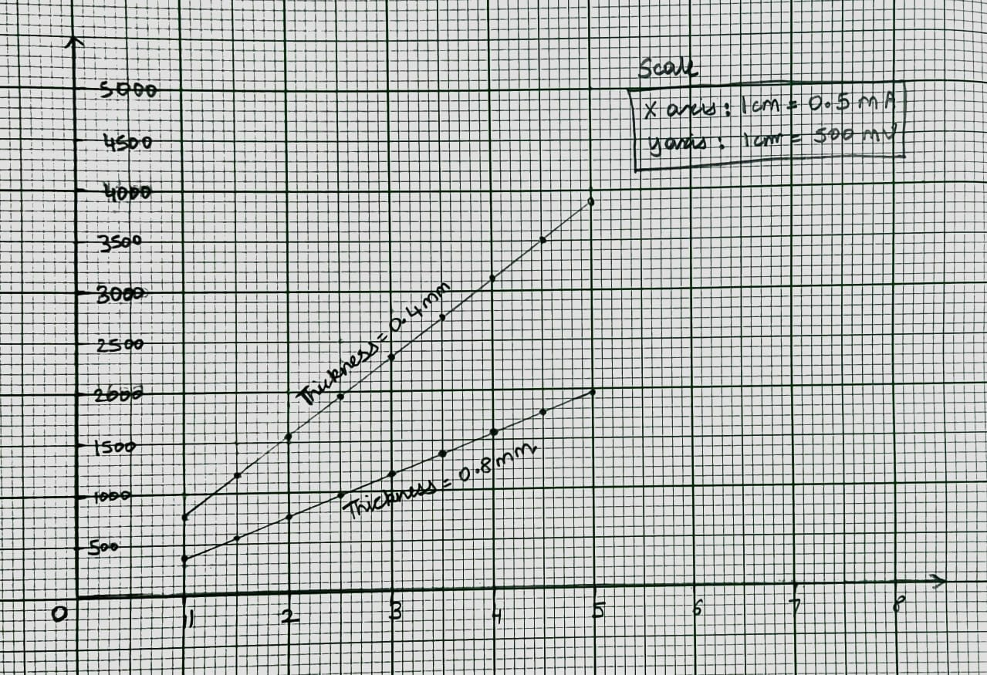
Formula: carrier concentration $n=\frac{B}{q × t × slope}$
Calculations
For t = 0.4mm

Slope = $\frac{1167.272-778.181}{1.5-1}$
Slope = 778.182

n = $\frac{B}{q × t × slope}$

where B = 0.447 gauss = 0.447 x 10⁻⁴ tesla
q = 1.6 x 10⁻¹⁹ C
t = 0.4 x 10⁻³ m

n = $\frac{0.447 x {10}^{-4}}{1.6 x {10}^{-19} × 0.4 x {10}^{-3} × 778.182}$

n = 9 x 10¹⁴

For t = 0.8mm

Slope = $\frac{583.636-389.091}{1.5-1}$
Slope = 389.091

n = $\frac{B}{q × t × slope}$

where B = 0.447 gauss = 0.447 x 10⁻⁴ tesla
q = 1.6 x 10⁻¹⁹ C
t = 0.8 x 10⁻³ m

n = $\frac{0.447 x {10}^{-4}}{1.6 x {10}^{-19} × 0.3 x {10}^{-3} × 389.091}$

n = 9 x 10¹⁴

Results:
The value of n for gold is 9 x 10¹⁴ for thickness 0.4 mm and 0.8 mm.

Home Assignment:
Keep Hall current (I_{H}) fixed at 3 mA. Vary Magnet current in steps of 0.5 A and note Hall voltage. Plot graph of Hall voltage (Y-axis) v/s Magnetic field* for any one thickness. Calculate carrier concentration using the formula: $n=\frac{I_{H}}{q × t × slope}$

*Find magnetic field for different magnet currents by selecting “Magnetic field v/s Current” from the “Select Procedure” drop-down menu of the simulator.

Observation table for Home Assignment:
Material: Germanium
Hall current: 3 mA
Thickness t = 0.4 mm
I ampere  (magnet current) | B gauss | V_{H} mV
1 | 0.1482 | 21.567
1.5 | 0.2223 | 32.350
2 | 0.2964 | 43.133
2.5 | 0.3706 | 53.917
3 | 0.4447 | 64.700
3.5 | 0.5188 | 75.484
4 | 0.5929 | 86.267
4.5 | 0.6670 | 97.050
5 | 0.7411 | 107.834

Graph

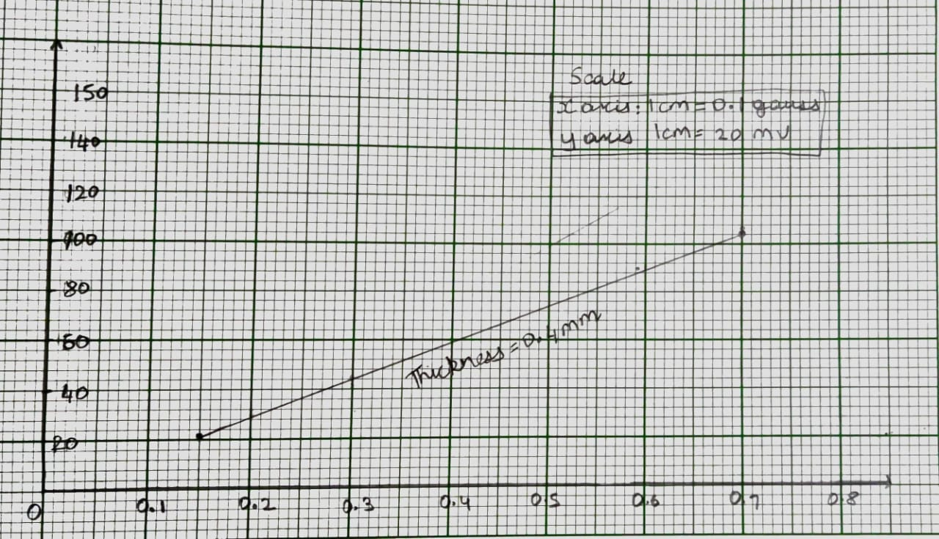

Calculations

Slope = $\frac{32.350- 21.567}{0.2223-0.1482}$

Slope = 145.519

Using formula: $n=\frac{I_{H}}{q × t × slope}$

where q = 1.6 x 10⁻¹⁹ C
t = 0.4 x 10⁻³ m

n $=\frac{3x {10}^{-3}}{1.6 x {10}^{-19} × 0.4 x {10}^{-3} × 145.519}$

we get,

n = 3.22 x 10¹⁷

